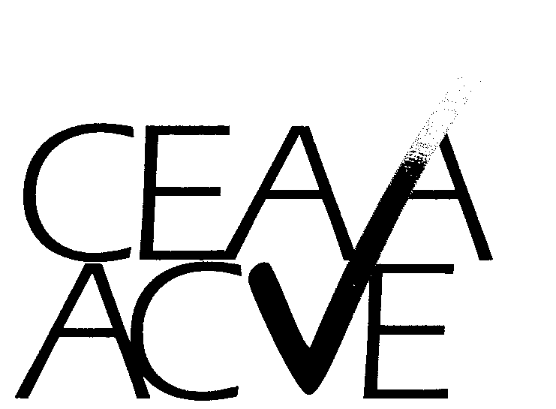 | Canadian Environmental Auditing Association  Association canadienne de vérification environnementale  1-6820 Kitimat Road -- Mississauga, Ontario -- L5N 5M3 -- Tel: 905-814-1160 -- Fax: 905-814-1158  website: www.ceaa-acve.ca

MEMBERSHIP FORM – Regular and Student Members

BENEFITS OF CEAA MEMBERSHIP
Annual CEAA membership entitles you to:
- Quarterly newsletter “The Auditorial”
- Listing in the online membership directory of all members, including certified auditors
- Complimentary copy of “General Principles and Practice Guidelines for Environmental Auditing”
- Special member registration rates for Annual Technical Conference and AGM

ADDRESS / CONTACT INFORMATION
Name: |  | Title:
Company:
Address:
City: |  | Province: | Postal Code :
Phone : | Fax: | Email:

MEMBERSHIP CATEGORY & ANNUAL DUES
Membership dues apply to the calendar year. Regular Membership Dues will be adjusted by prorating the annual amount on a quarterly basis on the January 1st renewal invoice following the year joined. Prorating does not apply to Student Membership Dues.  For Corporate Membership please contact the CEAA Executive Director (Registrar) at 905-814-1274 or admin@ceaa-acve.ca | Please Indicate Desired Membership Category and submit annual dues per payment options below.
 | CATEGORY  Regular _____  Student _____ | ANNUAL DUES  $ 195.00 + GST = C$ 206.70  $ 25.00 + GST = C$ 26.50

PAYMENT METHOD
A CHEQUE IS ENCLOSED IN THE AMOUNT OF: $ ____________  PLEASE CHARGE MY VISA IN THE AMOUNT OF: $ ____________ | Please make cheques payable to:  Canadian Environmental Auditing Association  Forward your completed membership form payment to CEAA by mail to:  1-6820 Kitimat Road  Mississauga, ON L5N 5M3  by fax to: 905-814-1158  by email to: admin@ceaa-acve.ca  GST: R891441933
VISA Card #: _____________________________________ Expiry: ________

Name of Cardholder: _____________________________________

Cardholder Signature: _____________________________________

INTERNAL USE ONLY: MEMBER NUMBER: _________ DATE ENTERED: _____________ PAGE 1 of 2

Canadian Environmental Auditing Association
Association canadienne de vérification environnementale
1-6820 Kitimat Road -- Mississauga, Ontario -- L5N 5M3 -- Tel: 905-814-1160 -- Fax: 905-814-1158
website: www.ceaa-acve.ca

MEMBERSHIP FORM - Regular and Student Members (Continued)

MEMBER PROFILE

In order to maximize the value of our database, we ask that you provide us with information about your professional affiliation and your interest and participation in environmental auditing.

A) Please indicate the sector(s) that most closely defines your professional affiliation. Please be as specific as possible.
 |  |  |  | 
 | Resource Sector |  | Government |  | Consulting
 | Manufacturing Sector |  | Financial / Insurance |  | Education / Training
 | Utilities Sector |  | Legal |  | Registrar
 | Industry – Other |  | Association |  | Other

B) Please indicate any other Environmental Auditing Associations or Environmental Organizations of which you or your firm are currently members:

As a member of the Canadian Environmental Auditing Association, I agree to abide by the CEAA Code of Ethics shown below.

CEAA CODE OF ETHICS

Each CEAA member shall endeavour to:

- be honest and candid and perform professional services with integrity and due care
- be competent, having the required skills, knowledge, and experience to perform the services undertaken
- continually seek to maintain and improve professional knowledge and skills
- serve the client in a conscientious, diligent, and efficient manner
- hold in strict confidence, except as required by law, all information concerning the business and affairs of the client acquired in the course of the professional relationship, and not use this information for personal gain
- remain free of any influence, interest, or relationship that impairs professional judgement, independence, or objectivity, while providing professional services
- commit to honest, thorough, and straightforward communication in the performance of professional duties
- not be associated with any report, statement, or representation known to be false or misleading
- conduct him- or herself toward other professional auditors with courtesy and good faith
- enhance the public regard for the profession at all times.

Signature _________________________________________ Date: _______________ PAGE 2 OF 2

